
Semester two examination, 2022
Question/Answer Booklet

HUMAN BIOLOGY
UNITS 1 & 2

Name: Marking Key

Teacher: ______________________________________________________

Time allowed for this paper

Reading time before commencing work: ten minutes
Working time for the paper: three hours

Materials required/recommended for this paper
To be provided by the supervisor
This Question/Answer Booklet
Multiple-choice Answer Sheet

To be provided by the candidate
Standard items: pens (blue/black preferred), pencils (including coloured), sharpener, correction fluid/tape, eraser, ruler, highlighters

Special items: up to three calculators, which do not have the capacity to create or store programmes or text, are permitted in this ATAR course examination

Important note to candidates
No other items may be taken into the examination room. It is your responsibility to ensure that you do not have any unauthorised material. If you have any unauthorised material with you, hand it to the supervisor before reading any further.

Structure of this paper

Section | Number of questions available | Number of questions to be answered | Suggested working time (minutes) | Marks available | Percentage of examination
Section One Multiple-choice | 25 | 25 | 30 | 25 | 30
Section Two Short answer | 7 | 7 | 80 | 90 | 50
Section Three Extended answer  Unit 1 | 1 | 1 | 40 | 15 | 10
Unit 2 | 2 | 1 |  | 20 | 10
 |  |  | Total | 150 | 100
Instructions to candidates

1. The rules for the conduct of the Western Australian examinations are detailed in the Year 12 Information Handbook 2022: Part II Examinations. Sitting this examination implies that you agree to abide by these rules.

2. Write your answers in this Question/Answer booklet preferably using a blue/black pen. Do not use erasable or gel pens.

3. Answer the questions according to the following instructions.

Section One: Answer all questions on the separate Multiple-choice answer sheet provided. For each question, shade the box to indicate your answer. Use only a blue or black pen to shade the boxes. Do not use erasable or gel pens. If you make a mistake, place a cross through that square, then shade your new answer. Do not erase or use correction fluid/tape. Marks will not be deducted for incorrect answers. No marks will be given if more than one answer is completed for any question.

Section Two: Write your answers in this Question/Answer booklet. Wherever possible, confine your answers to the line spaces provided.

Section Three: Consists of two parts each with two questions. You must answer one question from each part. Tick the box next to the question you are answering. Write your answers in this Question/Answer booklet

4. You must be careful to confine your answers to the specific questions asked and to follow any instructions that are specific to a particular question.

5. Supplementary pages for planning/continuing your answers to questions are provided at the end of this Question/Answer booklet. If you use these pages to continue an answer, indicate at the original answer where the answer is continued, i.e. give the page number.

Section One: Multiple–choice 30% (25 Marks)

This section has 30 questions. Answer all questions on the separate Multiple-choice answer sheet provided. For each question, shade the box to indicate your answer. Use only a blue or black pen to shade the boxes. Do not use erasable of gel pens. If you make a mistake, place a cross through that square, then shade your new answer. Do not erase or use correction fluid/tape. Marks will not be deducted for incorrect answers. No marks will be given if more than one answer is completed for any question.

Suggested working time: 40 minutes.

1. Follicle stimulating hormone is released from the

(a) ovaries.
(b) testes.
(c) corpus luteum.
(d) pituitary gland.

2. A Pap smear is a test that can be used to identify abnormal cells that could lead to the development of

(a) cervical cancer.
(b) prostate cancer.
(c) bowel cancer.
(d) breast cancer.

3. An imbalance in the action of osteoblasts and osteoclasts can most likely lead to the onset of which of the following disorders?

(a) osteoarthritis
(b) bone cancer
(c) osteoporosis
(d) rheumatoid arthritis

4. Which of the following correctly describes the importance of informed consent when carrying out an investigation involving human trials?

(a) Everyone has the right to have their identities kept confidential.
(b) Everyone has the right to know the possible risks, potential benefits and the objectives of the investigation.
(c) Nobody should be pressured into taking part in the investigation.
(d) Everyone has the right to remain anonymous throughout the investigation.

5. After a 12-week ultrasound a young couple were informed that there was a high probability of their baby being born with a chromosomal abnormality. The couple decided to get a diagnostic test to allow them to be better informed and prepared for the outcome at birth. Which of the following tests would the couple be able to get at this week of the pregnancy?

(a) chorionic villus sampling
(b) fetoscopy
(c) preimplantation genetic testing
(d) amniocentesis

6. Athletes have an increased risk of wearing away the cartilage found on the epiphyses of the bone that allow for smooth, frictionless movement. This can lead to a condition known as

(a) rheumatoid arthritis.
(b) spondyloarthritis.
(c) osteoarthritis.
(d) bursitis.

7. Which of the following correctly describes a difference between the processes of spermatogenesis and oogenesis?

(a) Spermatogenesis produces 4 mature haploid cells while oogenesis produces 1 mature haploid cell.
(b) Spermatogenesis occurs in the interstitial cells of the testes while oogenesis occurs in the ovaries.
(c) Spermatogenesis produces 4 haploid cells while oogenesis produces 1 diploid cell.
(d) Spermatogenesis produces polar bodies while oogenesis does not.

8. The outer layer of cells that spermatozoa break through in order to enter the cytoplasm of the ovum is known as the

(a) corpus luteum.
(b) zona pellucida.
(c) acrosome.
(d) corona radiata.

9. A man with Huntington’s disease and a woman without Huntington’s have two children. After genetic testing it is determined that one of their children will develop Huntington’s when they’re older, while the other is genetically healthy. What is the percentage probability of the couple having another child with Huntington’s disease?

(a) 25%
(b) 75%
(c) 50%
(d) 100%

10. The following points describe the steps, out of order, in the sliding filament model that explains the contraction of skeletal muscles from the point where the muscle cells are stimulated by a nerve cell.

(i) Myosin heads bind to actin forming a myosin cross-bridge
(ii) The myosin head bends and ADP and phosphate are released, pulling the actin over the myosin
(iii) Calcium ions enter the muscle cells and the presence of calcium exposes the myosin binding sites on the actin molecule
(iv) A new molecule of ATP attaches to the myosin and the cross-bridge detaches

Which of the following indicates the steps in the correct order?

(a) (i), (ii), (iii), (iv)
(b) (iii), (i), (iv), (ii)
(c) (i), (iii), (iv), (ii)
(d) (iii), (i), (ii), (iv)

11. Fertilisation typically takes place in the

(a) ovaries.
(b) cervix.
(c) uterus.
(d) uterine tubes.

12. Which of the following does not describe a structure of the alveoli that make them suited to the process of gas exchange?

(a) The alveoli are one-cell thick.
(b) The alveoli contain approximately 21% oxygen concentration from inhaled air.
(c) The alveoli are surrounded by a rich supply of blood capillaries.
(d) The alveoli are surrounded by a thin layer of moisture

Questions 13, 14 and 15 refer to the following diagram of the human male reproductive system.

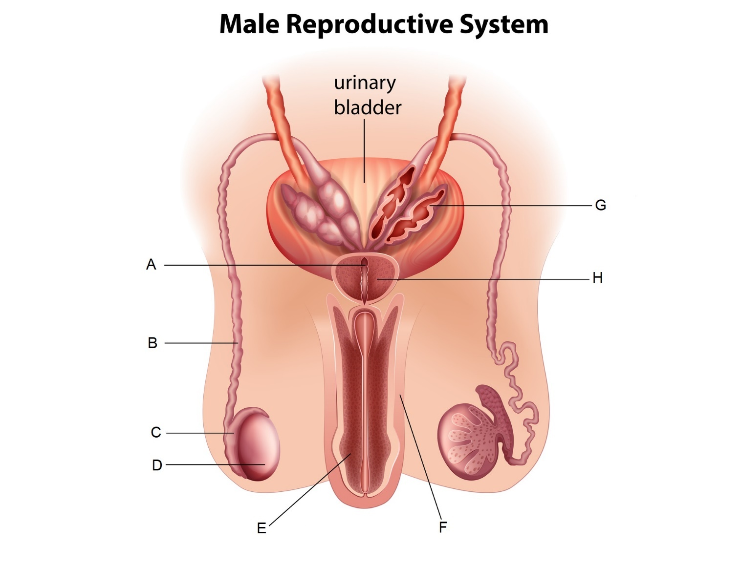

13. Which of the following labels indicates the epididymis?

(a) A
(b) B
(c) C
(d) D

14. Which of the following most correctly describes the function of the part labelled H?

(a) It secretes a fluid rich in sugars that makes up the majority of the seminal fluid.
(b) It secretes a small amount of fluid that acts as a lubricant.
(c) It secretes an alkaline fluid that helps to neutralise the acidity in the vagina.
(d) It secretes a fluid rich in proteins to provide spermatozoa with strength for swimming.

15. A relatively simple surgical procedure to sterilise males and prevent conception usually involves which of the following parts?

(a) A
(b) B
(c) C
(d) D

Questions 16, 17 and 18 refer to the following information.

Deidre and Georgina are conducting an investigation to see the change in mass of cylinders of potatoes when placed in varying concentrations of sucrose solutions. They find that when the potatoes are placed in distilled water they tend to increase in mass, while those placed in concentrated sucrose solutions tend to decrease in mass.

16. Which of the following correctly identifies the dependent variable in this investigation?

(a) the concentration of sucrose
(b) the change in mass of the potato
(c) the volume of sucrose solution
(d) the final mass of the potato

17. If one cylinder of potato in a highly concentrated sucrose solution has an initial mass of 1.55 g and a final mass of 1.44 g, which of the following correctly states the percentage change in mass?

(a) 11% increase
(b) 7% increase
(c) 11% decrease
(d) 7% decrease

18. Which of the following best explains why the potatoes in distilled water increased in mass?

(a) The sucrose moved into the potato through diffusion to balance out the concentration of sucrose in the potato and the water.
(b) The water had a higher solute concentration than the potato, so the water moved into the cells of the potato through osmosis.
(c) The potato had a higher solute concentration than the distilled water, so the water moved into the cells of the potato through osmosis.
(d) The cells of the potato gained mass as the starch inside was diluted by the distilled water.
19. During the process of flexion at the knee, the hamstring is contracting and the quadriceps are relaxing. Which of the following correctly describes the relationship between these two groups of muscles during this movement?

(a) The hamstring is the agonist while the quadriceps are the antagonists.
(b) The hamstring is the antagonist while the quadriceps are the agonists.
(c) The hamstring is the synergist while the quadriceps are fixators.
(d) The hamstring is the fixator while the quadriceps are synergists.

20. Pairs of homologous chromosomes line up together at the equator during

(a) metaphase.
(b) metaphase I.
(c) metaphase II.
(d) anaphase I.

21. With regards to inheritance of ABO blood groups, which of the following correctly identifies the mode of inheritance for the allele that results in no antigens presenting on the erythrocytes?

- X-linked recessive
(b) X-linked dominant
(c) Autosomal dominant
(d) Autosomal recessive

22. In a healthy, functioning nephron, active reabsorption of glucose mostly occurs in the

(a) proximal convoluted tubule.
(b) renal corpuscle.
(c) loop of Henle.
(d) distal convoluted tubule.

23. Glucose is a relatively large, water-soluble molecule that cells consistently use up during the process of cellular respiration. Glucose would most likely pass through the cell membrane through which of the following processes?

(a) osmosis
(b) simple diffusion
(c) facilitated diffusion
(d) active transport

24. Which of the following embryonic membranes will eventually form the foetal portion of the placenta?

(a) the chorion
(b) the amnion
(c) the yolk sac
(d) the allantois

25. After the first meiotic division during oogenesis, one of the cells created is smaller than the other with very little cytoplasm, while the other is larger and contains most of the cytoplasm. These two cells are, respectively, referred to as the

(a) first polar body and secondary oocyte.
(b) first polar body and primary oocyte.
(c) second polar body and secondary oocyte.
(d) second polar body and primary oocyte.

End of Section One

Section Two: Short answer 50% (108 marks)

Question 26 (19 marks)

A group of students were investigating the effect of exercise intensity on tidal volume of the lungs. They measured the tidal volume of five of their classmates at rest and then asked each individual to complete different types of exercise, increasing in levels of intensity, for 4 minutes at a time. Immediately after completing each exercise their tidal volume was then measured with a spirometer and recorded in litres (L).

The data is shown in the table below.

 | Tidal volume (L) after completing 4 minutes of exercise at different intensity levels
Type of Exercise | Individual 1 | Individual 2 | Individual 3 | Individual 4 | Individual 5 | Mean
At rest | 0.50 | 0.61 | 0.48 | 0.49 | 0.56 | 0.53
Walking | 1.21 | 1.10 | 1.16 | 1.18 | 1.42 | 1.21
Jogging | 2.25 | 2.23 | 2.18 | 2.04 | 1.98 | 2.14
Sprinting | 2.68 | 2.73 | 2.38 | 2.80 | 2.67 | 2.65

(a) Outline a possible hypothesis for this investigation. (1 mark)

Description | Marks
Answer must be a statement clearly linking independent and dependent variable, for example:
The more intense the exercise, the greater the tidal volume of the lungs | 1
Total | 1

(b) Identify one variable that was controlled during the students’ investigation. (1 mark)

Description | Marks
Any one from:
Length of time for each exercise/4 minutes for each exercise | 1
Participants all from the same class/all participants are students
All students measured immediately after exercise
Total | 1

(c) Complete the table above by calculating the mean tidal volume for ‘Walking’. (1 mark)

Description | Marks
See table for correct answer | 1
Total | 1

(d) Construct a graph of the average tidal volume for each type of exercise, not including the average for when the students were at rest, on the grid provided below. (5 marks)

Description | Marks
Descriptive title identifying independent and dependent variable | 1
Correctly organised with tidal volume on the y-axis | 1
Labelled both axes, with units identified on the y-axis | 1
Appropriate scale for the y-axis | 1
Correctly plotted column graph | 1
Total | 5
Example:

A spare grid is provided at the end of this Question/Answer Booklet. If you need to use it, cross
out this attempt and indicate that you have redrawn it on the spare grid.

(e) Suggest and explain one factor that may have affected the validity of the data.
(2 marks)

Description | Marks
Any relevant suggestion, with explanation linking to how it affects validity, example:
No rest time given between each type of exercise | 1
The tidal volume measured would not show the effect of each individual exercise/the tidal volume measured would represent a cumulative effect of duration of exercise on tidal volume (therefore not testing the hypothesis) | 1
Total | 2

(f) Tidal volume can be defined as the amount of air moved into the lungs during the process of inspiration. Describe the process of inspiration. (4 marks)

Description | Marks
Diaphragm contracts and flattens | 1
Intercostal muscles contract and pull ribs up and out | 1
This increases the volume in the chest cavity, and decreases the pressure | 1
Air enters the lungs moving from high to low pressure | 1
Total | 4

The students knew that an increase in the intensity of exercise causes an increase in contractions of the skeletal muscles, which requires the production of adenosine triphosphate (ATP).

(g) State one chemical processes that occurs during cellular respiration in the muscle cells that results in the production of ATP. (1 mark)

Description | Marks
Any one from:
Glycolysis | 1
Krebs cycle/citric acid cycle
Electron transport system/oxidative phosphorylation
Total | 1

The students were able to infer, from their scientific knowledge, that the increase in the tidal
volume of the lungs during exercise will increase the rate of gas exchange between the
blood in the capillaries and the air in the alveoli.

(h) Explain why there would be an increase in the rate of gas exchange as the skeletal muscles start working harder. (4 marks)

Description | Marks
Increase in gas exchange would increase amount of oxygen entering the blood | 1-4
While increasing the amount of carbon dioxide leaving the body/blood
Oxygen is needed for cellular respiration/to produce ATP (for working muscles)
Carbon dioxide is produced from cellular respiration, so more needs to be excreted from the lungs during exercise
Blood vessels would dilate, allowing more CO₂ to be removed and more O₂ delivered
Increase in pulmonary circulation/increase of blood flow to the lungs, bringing more CO₂ to the lungs (to maintain concentration gradient)
Total | 4

Question 27 (12 marks)

The diagram below represents a simplified view of the formation of a blood clot after a blood vessel has been damaged.
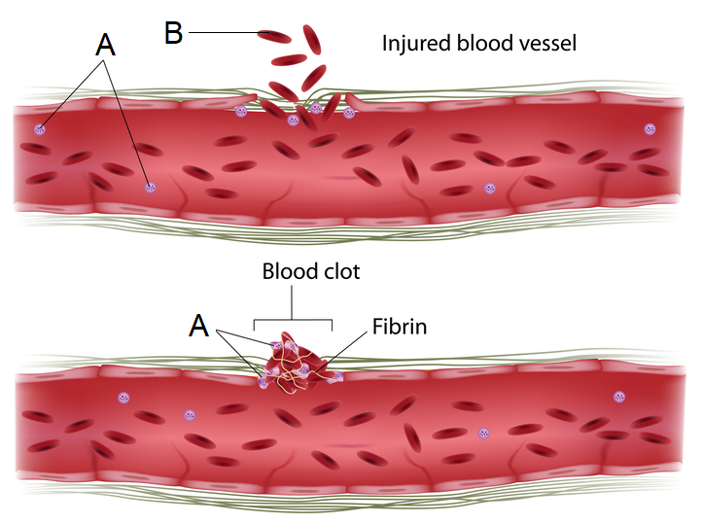
(a) Name of the blood cells labelled ‘A’ and ‘B’ in the diagram. (2 marks)

Description | Marks
A – platelets/thrombocytes | 1
B – red blood cells/erythrocytes | 1
Total | 2

A broken blood vessel can lead to an infection of foreign microorganisms. This can stimulate a specific type of blood cell, known as a neutrophil, to consume the microorganisms through phagocytosis, a special form of endocytosis.

(b) Describe the process by which the neutrophil consumes invading microorganisms.
(2 marks)

Description | Marks
Cell membrane folds around the microorganism (in the extracellular fluid) | 1
This encloses the microorganism in a vesicle (now in the cytoplasm of the cell) | 1
Total | 2

The X-linked genetic condition known as haemophilia means that people are unable to produce
certain clotting factors that result in the production of the meshwork of protein fibres known as fibrin.

The pedigree chart below shows the inheritance of haemophilia in a family.

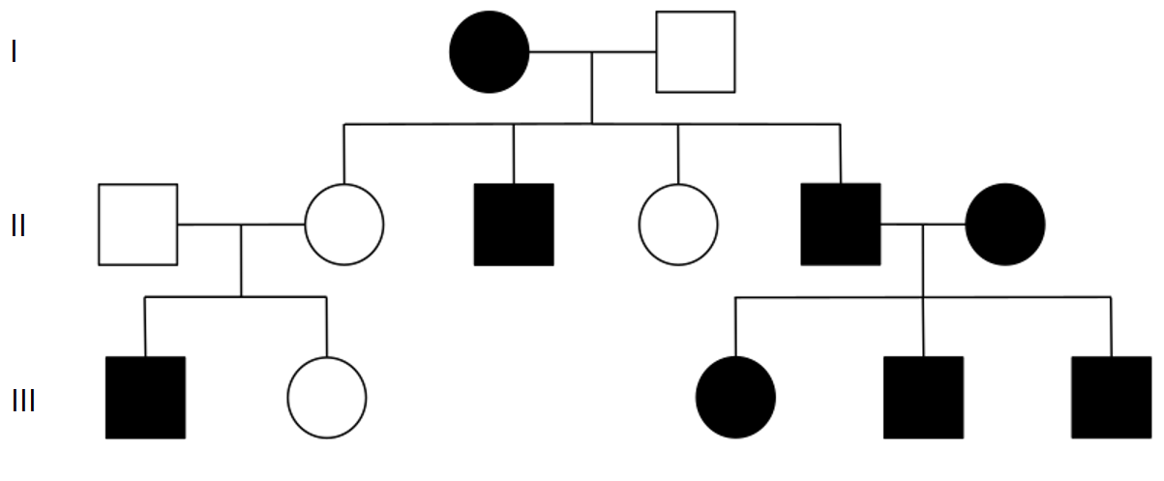

(c) State whether haemophilia is dominant or recessive. Justify your answer using evidence from the pedigree. (2 marks)

Description | Marks
Recessive | 1
Individual 1 and 2 in generation II are unaffected, but have an affected son/the unaffected mother in generation II has an affected son | 1
Total | 2

(d) Using the letters N and n, state the genotypes of individual II-2 and II-3. (2 marks)
Description | Marks
II-2 – X^{N}X^{n} | 1
II-3 – X^{n}Y | 1
Total | 2

(e) Is it possible for the two individuals in generation I to have a son without haemophilia? Explain your answer. (You may use a Punnett square as part of your explanation).
(4 marks)

Description | Marks
No | 1
The son will receive the X chromosome from the mother, who is homozygous recessive for haemophilia/who has two recessive alleles for haemophilia | 1-3
and will receive Y chromosome from the father, which will not carry any alleles
Therefore, will always be hemizygous for haemophilia/always inherit the haemophilia allele but cannot mask its effects
Correct Punnett square showing 100% inheritance of recessive allele by males, see example:
 | X^{n} | X^{n}
X^{N} | X^{N}X^{n} | X^{N}X^{n}
Y | X^{n}Y | X^{n}Y

All males affected by recessive allele

Total | 4

Question 28 (17 marks)

The diagram below shows the structures found in the human digestive system.

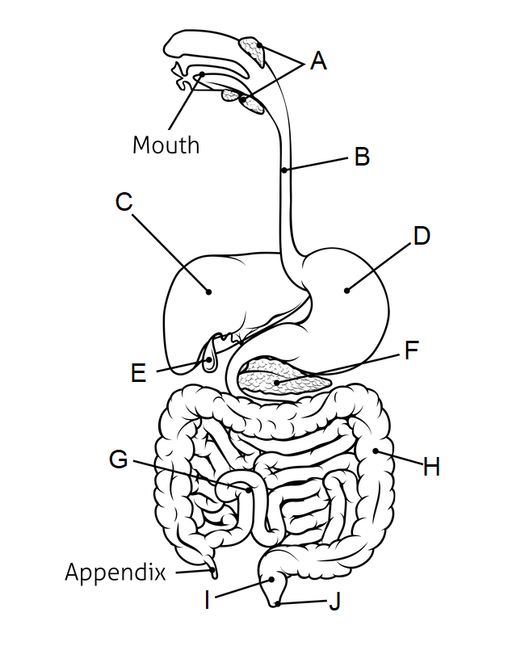

(a) Complete the table below based on the diagram given. (3 marks)

Description | Marks
A – salivary glands | 1
B – oesophagus | 1
E – gall bladder | 1
Total | 3

(b) The structure labelled C also plays an important role in metabolic pathways linked to excretion. Name and briefly describe/outline the process that takes place in structure C that leads to the production of urea, a substance excreted by the kidneys. (3 marks)

Description | Marks
Deamination | 1
An amino group (NH₂) is removed from an amino acid, resulting in the production of ammonia | 1
Ammonia is converted into (less toxic) urea | 1
Total | 3

Pancreatic cancer is a type of cancer which can result in the disruption of the normal functioning of the pancreas, which plays an important role in chemical digestion.

(c) Contrast mechanical and chemical digestive processes. (3 marks)
Description | Marks
Any three of the following contrasting points
Mechanical digestion breaks food into smaller pieces, chemical breaks large molecules into smaller molecules | 1-3
Mechanical digestion increases surface area of food, chemical digestion does not
Mechanical digestion doesn’t use enzymes, chemical digestion does
Mechanical digestion involves physical movements, chemical digestion does not
Mechanical digestion doesn’t change chemical composition, chemical digestion does
Total | 3

(d) State which label on the diagram correctly identifies the pancreas. (1 mark)

Description | Marks
F | 1
Total | 1

(e) Describe what cancer refers to, and explain how the growth of a tumour due to cancer could disrupt the normal functioning of an organ. (3 marks)

Description | Marks
Cancer refers to when cells divide uncontrollably/cancer is uncontrolled growth of abnormal cells | 1
Cancer cells do not develop into normal tissue cells | 1
These cancer cells will use up resources/’take the place’ of the normal cells and inhibit their normal functioning | 1
Total | 3

(f) Pancreatic cancer can lead to, among other things:

Malabsorption – a difficulty in absorbing essential nutrients, and;
Malnutrition – where the cells do not receive enough essential nutrients.

Explain how a dysfunction of the pancreas can cause these conditions. (4 marks)

Description | Marks
The pancreas produces a number of enzymes (essential for chemical digestion) | 1
If the pancreas is not working then the pancreatic enzymes will not be will be released/their production will be slowed which leads to less chemical digestion | 1
Less chemical digestion means nutrients may not be broken down into small enough molecules to be absorbed (therefore malabsorption) | 1
this means less nutrients are in the bloodstream so less nutrients reach the cells (therefore malnutrition) | 1
Total | 4

Question 29 (11 marks)

Proteins are one of the essential nutrients required for the normal functioning of cells and therefore the normal functioning of the entire human body. The production of specialised proteins called enzymes, among other things, also allows for the synthesis of other essential nutrients such as lipids and carbohydrates.

Protein synthesis is a complex process that can be divided into two stages – transcription and translation.

(a) State the name of the cell organelles where each of the stages of protein synthesis takes place. (2 marks)

Description | Marks
Transcription - nucleus | 1
Translation - ribosomes | 1
Total | 2

(b) Outline the basic structure of proteins. (2 marks)

Description | Marks
Made up of long chains of amino acids | 1
Bonded together with peptide bonds | 1
Total | 2

(c) Describe the process of transcription. (5 marks)

Description | Marks
DNA in the nucleus comes apart (due to RNA polymerase/helicase)
Reveals a template strand and coding strand (that are complementary to each other)
RNA polymerase transcribes the template strand of DNA
Using free floating RNA nucleotides to build mRNA
mRNA is made up of the complement of the template strand except for uracil where there would normally be thymine
A specific sequence of bases/stop codon tells RNA polymerase to stop copying when mRNA is finished building
Total | 5

One genetic disorder that can affect protein production is an autosomal, recessive condition known as phenylketonuria (PKU). This condition leads to a deficiency of an enzyme responsible for the breakdown of an amino acid called phenylalanine.

(d) Describe what is meant by an autosomal, recessive genetic condition. (2 marks)

Description | Marks
The allele is found on the autosomes/not found on the sex chromosomes | 1
It can be masked by a dominant allele/doesn’t show unless there are two copies of the allele | 1
Total | 2

Question 30 (12 marks)

The diagram below shows a cross-section of a blastocyst, a structure formed within 5-6 days after fertilisation takes place.
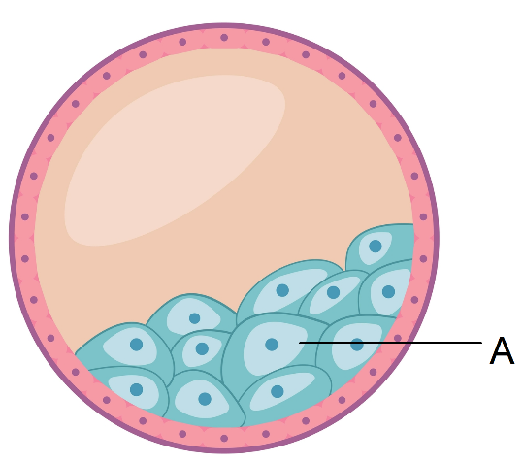

The part labelled A is a group of stem cells that will differentiate into all of the body cells that form the embryo.

(a) State the name given to the group of cells labelled ‘A’. (1 mark)

Description | Marks
Inner cell mass/embryoblast | 1
Total | 1

(b) The stem cells in part ‘A’ will initially differentiate into three layers known as the embryonic germ layers. Name two of these layers and identify one system, organ or tissue type that each layer can differentiate into. (4 marks)

Description | Marks
Any two of the following, 1 mark for naming layer and 1 mark for correctly identifying system/organ/tissue:
Ectoderm  Skin/hair/mammary glands/nervous system | 1-2
Mesoderm  Skeleton/muscles/connective tissue/heart/blood/stomach/urinary system | 1-2
Endoderm  Digestive system/lungs/respiratory system/thyroid | 1-2
Total | 4

Differentiation of stem cells occurs because of signals that influence gene expression, leading to cell specialisation. The study of the external factors that can affect gene expression is known as epigenetics.

(c) One way in which gene expression is regulated through epigenetics is due to changes in chromatin.

(i) Describe the structure of chromatin. (1 mark)

Description | Marks
DNA molecule wrapped around histones | 1
Total | 1

(ii) Name and describe one epigenetic factor that can alter chromatin and state the effect this factor has on gene expression. (3 marks)

Description | Marks
One of the following, 1 mark for name, 1 for description and 1 mark for effect on gene expression
Acetylation  An acetyl group attaches to the histone protein  This enhances gene expression | 1-3
Methylation  Methyl group attaches to DNA/CpG site on DNA  This inhibits gene expression | 1-3
Total | 3

Stem cells not only have the ability to differentiate into specialised cells, but they can also repeatedly divide by mitosis to form more stem cells.

(d) Outline the major events that occur in the following phases of mitosis.

(i) Metaphase (1 mark)

Description | Marks
Chromosomes line up at the equator of the cell | 1
Total | 1

(ii) Anaphase (2 marks)

Description | Marks
Pairs of (sister) chromatids are separated at the centromere | 1
and they are pulled towards opposite poles of the cell | 1
Total | 2

This page has been left blank intentionally

Question 31 (9 marks)

The diagram below shows the structures of the female reproductive system.

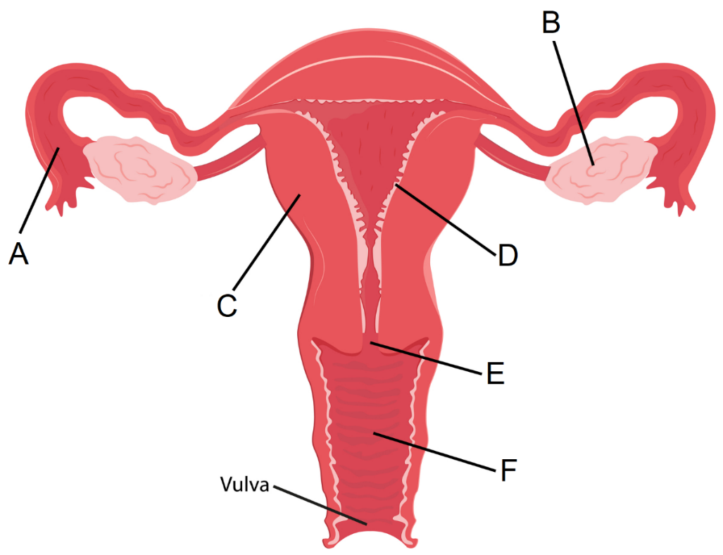

(a) Complete the table below, outlining the function of the structures indicated.
(2 marks)

Description | Marks
B – produces ova/oestrogen/progesterone | 1
D – (thickens/becomes more vascular) allows for zygote/blastocyst/embryo to implant/to maintain pregnancy if implantation occurs/is shed during menstruation if pregnancy doesn’t occur | 1
Total | 2

Gonorrhoea is a sexually transmitted infection (STI) that, if left untreated, can lead to blockages in the structure labelled ‘A’ in the diagram, and therefore infertility problems.

(b) Identify whether gonorrhoea is a viral or bacterial infection, and state the normal treatment for this STI. (2 marks)

Description | Marks
Bacterial | 1
Through the use of antibiotics | 1
Total | 2

(c) Suggest one way in which a gonorrhoea infection could be prevented. (1 mark)

Description | Marks
Abstinence/use of condom/female condom/femidom/limit number of sexual partners/test for STI prior to intercourse | 1
Total | 1

(d) Explain how a blockage in structure ‘A’ could lead to infertility and state one other STI that could cause infertility in females. (4 marks)

Description | Marks
The egg/secondary oocyte is normally released into ‘A’/the fallopian tube where it is fertilised/the zygote travels through the fallopian tube to reach the uterus | 1
If blocked, the sperm cannot reach the egg/secondary oocyte for fertilisation/the fertilised egg cannot reach the uterus | 1
Therefore, conception cannot occur/implantation cannot occur which means a woman is unable to fall pregnant (=infertility) | 1
Chlamydia | 1
Total | 4

Question 32 (10 marks)

Parturition, or birth, is the point where the foetus is expelled from the woman’s body. After the birthing process there are a number of changes that occur in the circulatory system of the newborn.

(a) The birth process is typically divided into three stages of labour. Outline any two processes/events that occur in each stage of labour. (6 marks)

Description | Marks
First stage (any two):  The cervix is shortened  The cervix dilates  Contractions of the uterus become more regular/occur at regular intervals  Foetus moves more deeply into the pelvis  Formation of a single, curved passage (birth canal) | 1-2
Second stage (any two):  Amnion bursts and amniotic fluid is released  Contraction of the abdominal muscles occurs  The baby’s head turns to face the mother’s back  Crowning occurs  Once head emerges, baby rotates its head towards mother’s hips  Foetus is expelled from the uterus/delivery of the foetus | 1-2
Third stage (any two):  The umbilical cord is clamped in two places and cut  The uterus continues to contract forcing out the afterbirth  Uterus contractions squeeze shut the blood vessels (to prevent loss of blood) | 1-2
Total | 6

The foramen ovale is an opening between the two atria that is present in the foetal heart. It provides the blood with a different pathway compared to normal circulation through the heart.

(b) Name and describe the function of two other structures found in the circulatory system of a foetus compared to a newborn baby. (4 marks)

Description | Marks
Ductus arteriosus | 1
Directs blood away from the lungs to flow directly into the aorta | 1
Ductus venosus | 1
Directs blood away from the liver into the inferior vena cava | 1
Total | 4

End of Section Two

Question 33 (15 marks)

Connective tissue is one of the four basic tissue types in the human body and can be defined based on its structure by the presence of non-cellular material known as matrix. Bone and cartilage are both examples of connective tissues that provide the body with support, protection and movement.

(a) Describe the structure and function of three different types of cartilage in the human body.
Description | Marks
Types of cartilage:
Hyaline cartilage contains closely packed/densely packed collagen fibres | 1
Hyaline cartilage provides strength and flexibility/provides a smooth surface for movement at the joints | 1
Fibrocartilage has a coarse appearance/has collagen fibres that are not packed as densely as hyaline cartilage/parallel bundles of collagenous fibres | 1
Fibrocartilage provides support in weight-bearing locations/site of heavy pressure (such as the knee/between the vertebrae) | 1
Elastic cartilage had obvious elastic fibres with not so closely packed collagen fibres | 1
It provides elastic support in specific locations (such as the outer ear) | 1
Total | 7
(7 marks)

(b) Describe the structure and range of movement of four different types of synovial joints. (8 marks)
Description | Marks
Any four from the following, 1 mark for description of structure and 1 mark for description of range of movement
Ball and socket joints have a spherical head that fits into a concave/cup-like cavity  They allow for movements in all directions (except where inhibited by ligaments) | 1-2
Hinge joints form when a convex surface meets a concave surface  They allow for movement on one plane only/allow for flexion and extension only | 1-2
Pivot joints have a pointed/rounded/conical end that connects with a ring made of bone and ligament  They allow rotational movements/movement around an axis | 1-2
Gliding joints are made up of irregular bones/exist between two bones that are flat (or nearly flat) at the meeting point  They allow side-to-side and back-and-forth movements | 1-2
Saddle joints form from two saddle-shaped bones/form from a concave and convex shape in different directions  They allow side-to-side and back-and-forth movements | 1-2
Condyloid/ellipsoid joints have a slightly convex bone combining with a slightly concave bone  They allow for up and down and side-to-side movements | 1-2
Total | 8

Unit 2

Question 34 (20 marks)

Contraception methods offer the opportunity for couples to plan if and when they wish to embark on the trials and tribulations that come with parenting. Although there are many different methods of contraception, one of the most effective methods in preventing fertilisation involves the use of synthetic hormones.

(a) Name and describe the function of the hormones that normally regulate the male reproductive system and the ovarian and menstrual cycle in females. (12 marks)

Description | Marks
Follicle stimulating hormone | 1
Causes production of sperm/to regulate spermatogenesis in seminiferous tubules | 1
Causes the maturation of the follicle and promote oogenesis in the ovarian cycle | 1
Luteinising hormone | 1
Cause the production of testosterone from interstitial cells in testes | 1
Causes ovulation/formation of the corpus luteum in the ovarian cycle | 1
Testosterone | 1
Testosterone causes maturation of the sperm/stimulates secondary male sexual characteristics | 1
Oestrogen | 1
Stimulates the endometrium to thicken and develop in the menstrual cycle | 1
Progesterone | 1
Causes the thickening and maintains the endometrium in the menstrual cycle | 1
Total | 12

(b) Explain how the combined oral contraceptive pill, and emergency hormonal contraceptives (the morning-after pill), influence the hormonal control of the ovarian and menstrual cycle to prevent fertilisation. (8 marks)
Description | Marks
The combined pill contains (synthetic) progesterone and oestrogen | 1-5
It is taken throughout the ovarian & menstrual cycle/progesterone and oestrogen levels remain high throughout the whole cycle
When the progesterone and oestrogen levels are high, the levels of FSH and LH are low/the levels of pituitary hormones/gonadotropins are suppressed
The low FSH means follicle does not develop/the egg is not matured
The low LH means egg/secondary ooctye cannot be released/ovulation never occurs
Therefore the egg is never available for fertilisation (in the fallopian tube)
The morning-after pill contains high levels of progesterone only | 1
If taken within the correct timeframe/before ovulation occurs this high level of progesterone delays the release of an egg/delays ovulation | 1
Because sperm can survive for up to 5-7 days this decreases the likelihood of an egg being available for fertilisation | 1
Total | 8

Question 35 (20 marks)

Meiosis, a process that involves DNA replication, chromosome pairing and nuclear divisions, produces unique sets of gametes for reproduction. The complex process ensures there is variation in the genotypes of offspring, which will lead to variation in phenotypes.

(a) Describe the structure of DNA and explain how this structure allows for the replication of DNA. Include in your answer a brief outline of the steps involved in DNA replication.
(10 marks)

Description | Marks
DNA structure:
DNA is made up of two (anti-parallel) strands of nucleotides/double stranded structure | 1-5
Nucleotides made up of a phosphate group, a deoxyribose sugar and a nitrogen base
The sugar of one nucleotide bonds with the phosphate of another/there is a long chain of alternating sugar and phosphate molecules for each DNA strand/sugar-phosphate backbone
Attached to each sugar is a nitrogen base
4 different nitrogen bases named adenine, thymine, guanine and cytosine
The bases for each strand are bonded together with hydrogen bonds
Adenine only bonds with thymine
Cytosine only bonds with guanine
The DNA twists into a double helix shape/coiled into a spiral
Explain why structure allows for replication of DNA + steps in DNA replication
Hydrogen bonds between bases are relatively weak and easily broken | 1-2
This means the nitrogen bases are easily exposed to allow for replication to occur
DNA can replicate itself because of the way its double strands relate to one another/the complementary nature of the two strands
Enzyme helicase separates the two strands of DNA | 1-3
Each strand of DNA acts as a template to make new complementary strands of DNA
DNA polymerase adds new free-floating nucleotides to form the new strands of DNA
DNA ligase combines short sections of DNA
This creates two new identical molecules of DNA
Total | 10

(b) Describe three processes that occur during meiosis that lead to variation. (10 marks)

Description | Marks
Crossing over:
When homologous chromosomes pair up (during prophase I) they exchange sections of DNA | 1
The chromatids for each pair cross (at the chiasma), break and exchange segments | 1
This leads to a new combination of alleles in the gametes that is different from the parent cell/recombination | 1
Random assortment
When homologous pairs line up/separate they do so at random | 1
The way one pair separates is unaffected by another/each pair separates independently | 1
This takes place for all 23 pairs of chromosomes and leads to a new combination of chromosomes that will differ from the parent cell | 1
Non-disjunction
When a pair of chromosomes fails to separate during anaphase I or II | 1-4
One daughter cell will receive an extra chromosome, one will be missing one/gametes will either have 22 or 24 chromosomes (instead of 23)
When the gamete with the extra or missing chromosome combines with another gamete during fertilisation this can lead to
trisomy – where there are three chromosomes when they should be a pair, or
monosomy, where there is one chromosome when there should be a pair
Total | 10

End of questions

